**Assignment 17.3**

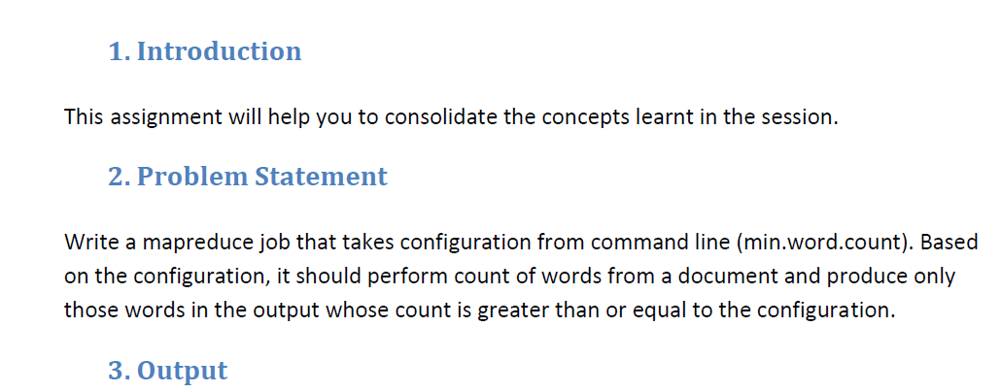

**Driver Class:**

* In Driver class we are making it the extends configured class
* implementing tool interface and tool runner static method run will creates a configuration object before the run method.

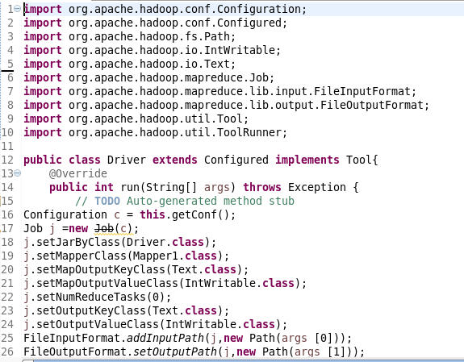

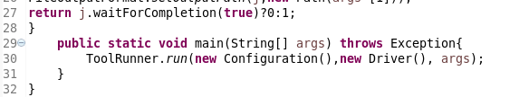

**Mapper Class:**

* In Mapper class, hashmap is used
* If hashmap contains the word count it will be incremented
* else a count of 1 will be made.
* Words will be counted only if the occurrence of word is greater than or equal tothe given value

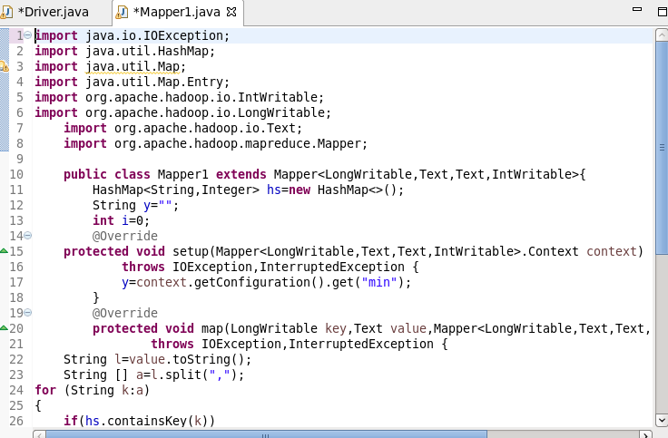

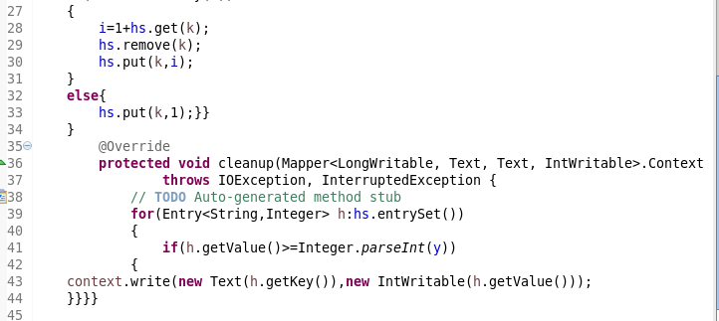

**RUNNING JAR**

**It is specified with min count of 3 by giving the** name=3 **as highlighted below**

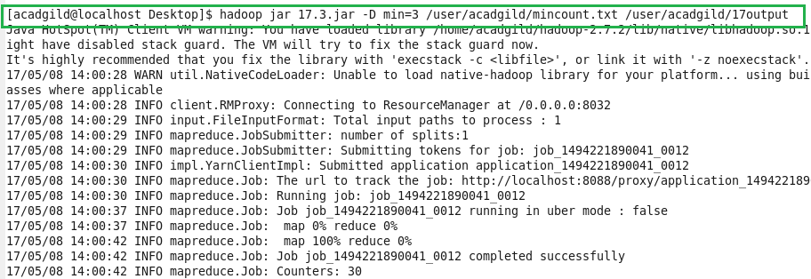

**Input :**

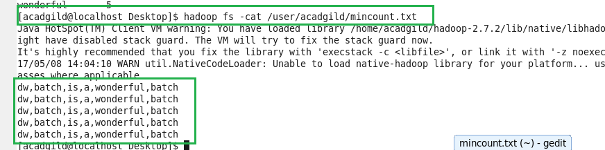

**Output:**

